Arbor Day
Friday, April 29, 2022, 4:00 PM
Tree City Site at Post Office
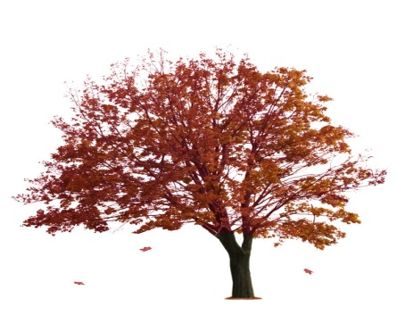
J. Sterling Morton was a newspaper editor who had moved from Michigan to Nebraska. Trees were abundant in Michigan but not in Nebraska. To address this dearth of trees Mr. Morton originated the first American Arbor Day in Nebraska City, Nebraska, on April 10, 1872. (His son Joy Norton was the founder of the Morton Salt Company and its iconic blue cylinder salt container.) It was Joy Morton who donated the family’s 52 room mansion (a look alike to the White House) to the Arbor Day Foundation. The Foundation operates this home as a museum and the 72 acre park surrounding the home.
Today “Arbor Day” is celebrated around the world from Iran to Israel, from China to Saudi Arabia, Russia to Cuba.
Put-in-Bay, Ohio, has been named a Tree City USA by the Arbor Day Foundation in honor of its commitment to the goals and principles of the Arbor Day Foundation: a tree commission, a tree-care ordinance, an annual community forestry budget, and an Arbor Day observance and proclamation.

Put-in-Bay‘s Arbor Day Celebration will take place on Friday, April 29, 2022, 4:00 pm, at the Village Arbor Day site adjacent to the Put-in-Bay Post Office. The Council of the Village of Put-in-Bay has allocated funds for Arbor Day expenses. During the celebration, two trees, a Hop Tree and a Spice Bush, will be planted by members of the community.

In the 19th century, German immigrants in Texas used hop tree seeds in the place of hops to make beer. Thus “Hop Tree” got its common name. The hoptree or wafer ash is a host plant for the Giant Swallowtail butterfly. A Spicebush is named for its spicy, fragrant leaves and stems. It is native to the woodlands in the Midwest and a host plant for the Spicebush Swallowtail.

Arbor Day translates to “tree” day from the Latin origin of the word arbor. National Arbor Day is celebrated on the last Friday in April.

Members of the Village of Put-in-Bay Tree Commission are Lisa Brohl, Kelly Faris, and Kendra Koehler.

The Village of Put-in-Bay Tree Commission will celebrate this Arbor Day in compliance with the CDC Covid recommendations.

