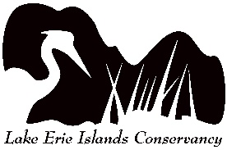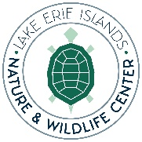
Garlic Mustard Pull Competition!
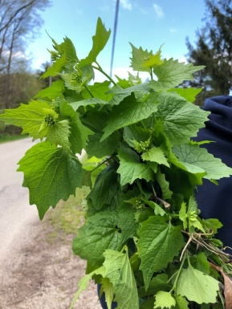
Saturday, May 7
9:00am-2:00pm
Cooper’s Woods Preserve
The City of Green near Akron, Ohio and Portage Parks has issued the Put-in-Bay Township Park District a challenge as to which community can pull the most garlic mustard in a day! We have accepted the challenge but need your help and lots of volunteers. Brendan Morgan of EnviroScience will be here Saturday May 7 from 9:00 am-2:00 pm at the Cooper’s Woods parking lot to arm us with strong garbage bags. Come for whatever time you are available.
Bring garden gloves to wear if you can.We will have some garden gloves for those who need them still. We will also have cold drinking water in a large cooler container-please bring your own water bottle for a refill!
There will be a prize for each person pulling at least two bags of garlic mustard and a grand prizes for those pulling the most that day! Register by emailing leiconservancy@gmail.com or by texting Lisa Brohl at 419-366-2087. Walk ins welcome but registering will help us in planning for prizes.
We have met the enemy and it is garlic mustard!
Don’t Give Up the Pull!

